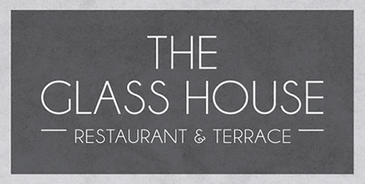

NIBBLEs
Nocellara olives 5 gf ve df
Warm mixed bread, garlic butter, rosemary oil & balsamic 6.5 v
Starters
Seasonal soup of the day, toasted focaccia 7 (gf available)
Smoked mackerel pate, horseradish crème fraiche, toasted sourdough 9 gf available
Panko cod cheeks, spiced lentils, curry oil 9 gf
Pulled beef croquettes, pomme puree, red wine jus 9.5 gf
Smoked tofu, black sesame puree, spring onion slaw 9 v gf (ve available)
MAIN Courses
Pan-fried calves liver, truffle mash potato, charred carrot, tenderstem, bourguignon sauce 20 gf
Fishermans scotch egg, spinach, pinenut & parmesan veloute 18 gf
Cider braised pork belly, celeriac fondant, braised red cabbage, grain mustard jus 18 gf
Seared salmon fillet, crushed butter beans & leeks, crispy kale, prawn velouté 19 gf
Vegan vegetable tagine, lemon couscous, mint yoghurt, toasted pitta 15 ve
CLASSIC
Trenchmore farm beef burger, Brioche bun, sweet chilli jam, gherkin, tomato, baby gem & fries 16 (gf available)
Add cheddar 2, smoked bacon 2, field mushroom 1
Beer battered haddock, chunky chips, crushed peas, tartare sauce, charred lemon 16.5 gf df
225g Sirloin steak, truffle and parmesan fries, crispy onion rings, grilled field mushroom & tomato 28
Add peppercorn sauce 2, red wine jus 2 or garlic butter 2
SALADS
Caesar salad, baby gem, croutons, parmesan 9 v
Kimchi, sesame quinoa, soy beans, rocket, avocado, omega seeds, citrus dressing 13.5 ve gf
Superfood salad- roasted sweet potato, pickled beetroot, flaked almonds, boiled egg, spinach 13 v gf
Add anchovies 1.5, smoked bacon 2, chargrilled chicken 4, crispy halloumi 3.5, smoked salmon 4.5, panko prawns 4.5
SIDES
Parmesan & truffle fries 5.5 v gf Chunky chips 3.5 ve gf Sweet potato fries 4.5 ve gf
Garlic buttered greens 4 v gf
Tenderstem broccoli & chilli, coriander & sesame 5 gf v Wilted spinach, parmesan & pinenuts 5 gf v
Please notify your server of any allergies, A discretionary service charge of 12.5% is added to your bill.





