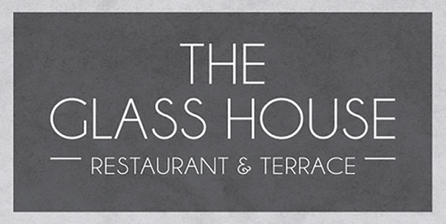

NIBBLEs
Nocellara olives 5 gf ve df
Warm mixed bread, garlic butter, rosemary oil & balsamic 6.5
Starters
Seasonal soup of the day, toasted focaccia 7 (gf available)
Prawn cocktail, paprika mayonnaise, brown bread & butter 9 gf available
Pulled beef croquettes, pomme puree, red wine jus 9.5 gf
Smoked mackerel pate, horseradish creme fraiche, toasted sourdough 9 gf available
Smoked tofu, black sesame puree, spring onion slaw 9 ve gf
Sunday roasts
Roast aged sirloin 19.5
Slow cooked pork belly, apple puree 19.5
Chicken breast with pork, sage & onion stuffing 17.5
Vegetarian nut roast 16 ( ve available)
All served with crushed carrot & swede, roasted parsnip, slow cooked red cabbage, rosemary & garlic roast potatoes, seasonal greens, Yorkshire pudding & red wine gravy
SIDES
Parmesan & truffle fries 5 v gf Chunky chips 3.5 ve gf Sweet potato fries 4.5 ve gf
Roast potatoes 4.5 gf Cauliflower cheese & crispy onions 5.5 Extra Yorkshire 1 Pork, sage & onion stuffing 4
cLASSIC
200g Trenchmore farm beef burger, brioche bun, chilli jam, tomato, gherkin, baby gem, fries 15.5 gf available
Beer battered haddock, chunky chips, crushed peas, tartare sauce 16.5 df gf
Salads
Caesar salad, baby gem, croutons, parmesan 8 v
Kimchi, sesame quinoa, soy beans, rocket, avocado, omega seeds, citrus dressing 13.50 ve gf
Superfood salad- roasted sweet potato, pickled beetroot, spinach, flaked almonds, boiled egg,13 v gf
Add- anchovies 1.5-bacon 2 - crispy halloumi 3.5 - chicken 4 - smoked salmon 4.5
panko prawns 4.5

Please notify your server of any allergies. A discretionary service charge of 12.5% is added to your bill.





