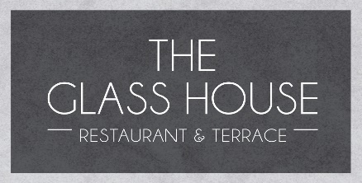

AFTERNOON TEA
Savoury
Warm sausage roll and red onion marmalade
Cream cheese & smoked salmon blinis

Selection of finger sandwiches
Egg mayonnaise
Chicken and bacon
Prawn Marie rose

Sweet selection
Lemon cheesecake
Chocolate & orange brownie torte
Glazed banana loaf
French macarons
Freshly baked fruit & vanilla scones
Clotted cream
Strawberry & blackcurrant jam
Classic Afternoon Tea £29.50 per person
Sparkling Afternoon Tea £35.50 per person Includes a glass of Prosecco
Nyetimber Afternoon Tea £39.50 per person Includes glass of Nyetimber
Afternoon tea must be booked 48 hours in advance
£10 cancellation charge per person if cancelled within 48 hours
Upon booking, please notify us of any allergies or dietary requirements
A discretionary service charge of 12.5% will be added to your bill

