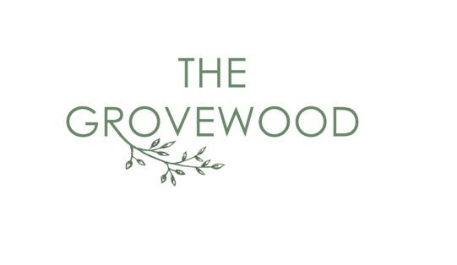
D I N N E R M E N U

S T A R T E R S
Marinated olives (VG/GF) 5.5
Flatbread & hummus (VGA/GFA) 5.5
Antipasti (GFA/VG) 18
Sun dried tomatoes, mixed olives, hummus, roasted red peppers, pickled chillies, artichokes, chargrilled aubergine, rocket & toasted flatbread
Soup of the day (VG/GFA) 8
Chefs’ choice of toasted bread
Salsify 9 (GF/VG)
Salsify, roasted celeriac puree, chestnut crumb, mushroom powder & pickled shimeji
Lamb kofta 12
Sweet chilli sauce, sesame & lime slaw
Mac ‘n’ cheese 9.5
Baked mac ‘n’ cheese, pulled BBQ pork, cheddar, mozzarella, parmesan & pangritata

M A I N S
Market fish (GF) - see your server for more details
Lemon buttered peas, homemade tartare sauce, lemon with chips
Beef short rib (GF) 30
Braised short rib of beef, bacon, pearl onions, chestnut mushroom, wholegrain mustard mash, Bourguignon sauce
Vegetable tagine (VG/GF) 16.5
Sweet potato, peppers, red onion, aubergine, courgette, fennel with cauliflower rice. coriander & chilli
Duck leg (GF) 23
Confit duck leg, slow cooked puy lentils, roasted roots & cherry glaze

F R O M T H E G R I L L
Served with chips & rocket dressed with tomato oil
10oz Hereford rump (GF) 32
Flavourful, tender cut of beef taken from the shoulder
(Chef recommends medium rare)

Chefs’ choice of steak (GF)
please ask your server for details

Butterflied chicken breast (GF) 16
Chargrilled butterflied chicken breast
P A S T A & S A L A D S
Add Chicken 7 / halloumi 6 / prawns 7.5 / spinach falafel 5.5
Grovewood salad (VG/GF) 13.5
Butternut squash, tri-coloured quinoa, red onion, olives, rocket, lemon & sumac dressing
Caesar salad (GFA) 13.5
Gem Lettuce, buttermilk Caesar dressing, anchovies, parmesan & croutons
Gnocchi (GF/VGA) 15.5
Wild mushroom, truffle, leek pesto, rocket, pinenuts & parmesan
Linguine (GFA) 13.5
Peppers, roasted red onion, cherry tomato, Cajun cream, rocket & parmesan

B U R G E R S
Served in a burger bun with chips
Grovewood burger 20 – Beef patty, pulled BBQ pork, Monterey Jack, burger sauce, gem, tomato & gherkin

Chicken burger (GFA) 18 – Buttermilk marinated chicken thigh, house seasoning, blue cheese mayo, hot sauce, gem lettuce

Falafel burger (VG) 13 – spinach and falafel patty, gem, spicey tomato & caramelised onion chutney
)

S I D E S & U P G R A D E S

Chips (GF/VG) 4.5
Truffle parmesan upgrade 3
Grovewood coleslaw (GF/VG) 4.5
Maple glazed root veg (GF/VGA) 6
Garlic Ciabatta (GFA/V) 5
House salad (GF/VG) 4.5
Smashed cucumber- Gochujang, soy & sesame (GF/V) 4.5

Homemade BBQ Sauce (GF) 4.5
Peppercorn sauce (GF) 4.5
Chimichurri sauce (GF/VG) 4.5

Add Cheese (GF) 2.5
Add smoked streaky Bacon (GF) 3
Add chargrilled chicken breast (GF) 7
Add halloumi (GF/V) 6
Add spinach falafel (VG) 5.5
Add prawns (GF) 7.5
Add cured meats (GF) 6.5
Add extra bread (VG/GFA) 2

