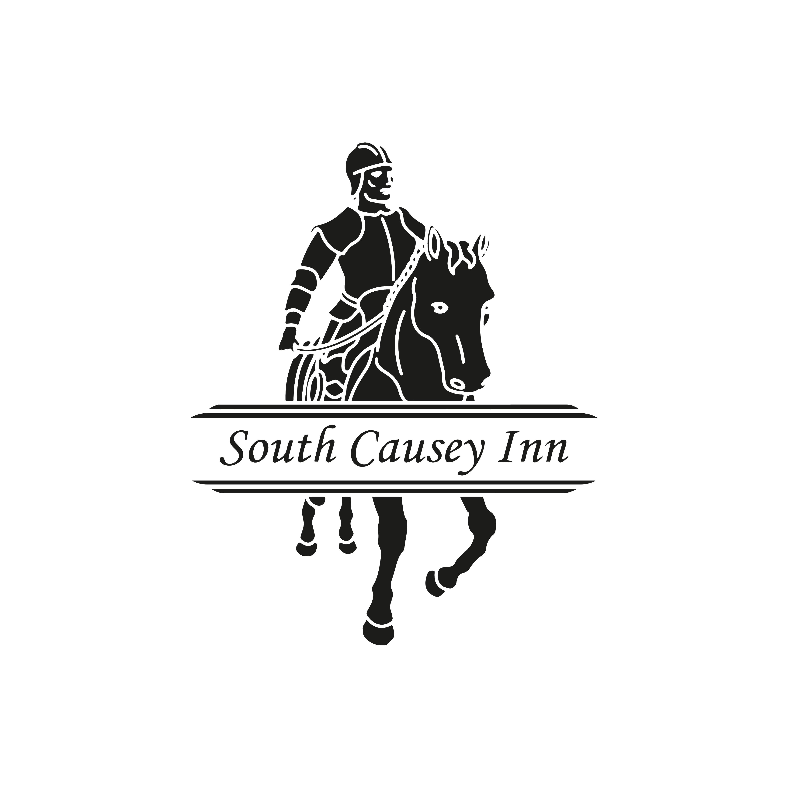

Accessibility Guide for South Causey Inn
enquiries@southcausey.co.uk, 01207 235 555, http://www.southcausey.co.uk/
Contact for accessibility enquiries: Susan Moiser, Katy Burke, Rebecca Jones, Clare Carter

Welcome
South Causey Inn is a family-owned hotel with a ‘country feel’ family pub, restaurant, and cocktail bar and is recognised for genuinely kind and generous service. The hotel has 55 unique bedrooms and suites, from cosy en suite rooms to themed suites with private parking, luxury hot tubs, plush interiors, waterfall showers, private gardens, copper baths, and more.
The hotel is perfectly positioned to offer unique cultural experiences in an incomparable location between Durham and Newcastle Cities, whilst also embracing Northern history, with the world famous Beamish Museum, and Tanfield Railway just a stone's throw away.
Watch the video: Around the Inn

At a Glance

Level Access
- There is level access from the main entrance to:

Bedrooms
- We have non-allergic bedding.

Hearing
- Bedroom TVs have subtitles.

Getting here
South Causey Inn
Beamish Burn Road
Stanley
DH9 0LS

Travel by public transport
- You can get to South Causey Inn by bus and train.
- Kip Hill Garage The bus stop is 0.1 miles / 0.2 km from South Causey Inn.
- The nearest train station is Chester-le -Street. The train station is 6.5 miles / 10.5 km from South Causey Inn.

Travel by taxi
- You can get a taxi with Stanley Travel by calling 01207 237424. The taxi company has a wheelchair accessible vehicle.

Parking
- We have a car park. There are accessible parking spaces. The parking is less than 50 metres from the main entrance. Parking is free.
- There is a drop-off point at the main entrance. The drop-off point has a dropped kerb.
- From the car park to the entrance, there is level access. There is a permanent ramp.
- The path is sloped.
- We have a transport service, to take visitors from the car park to the main entrance.

Arrival & Getting around inside

Path to main entrance
- From the street to the main entrance, there is level access.
- There is a permanent ramp.
- The path is sloped.

Main entrance
- The main entrance has level access.
- The main door is side hung and manual.

Bedrooms
- All bedrooms have windows.
- Bedrooms have ceiling lights, bedside lamps and natural daylight.
- Lights are LED. Some lights can be controlled independently.
- TVs have subtitles.
- All bedrooms are non-smoking.
- We have non-allergic bedding.
- Some bedrooms have fitted carpets.
- All bedrooms are ensuite.

Public Toilet
- There is a public toilet for disabled visitors.
- From the main entrance to the public toilet, there is level access.
- There is a permanent ramp.

Place to eat and drink
- There is background music sometimes.
- We cater for vegetarian specific diets.

Getting around outside

- From the main entrance to the smoking area, there is level access. The smoking area has a shelter.

